**How To Create a New User**

1. login to <http://amplexda.dev.coinbug.com/admin>
2. choose ‘Website Admin’ link ( or go to <http://amplexda.dev.coinbug.com/scms> )
3. select ‘security’ from the navigation at the far left

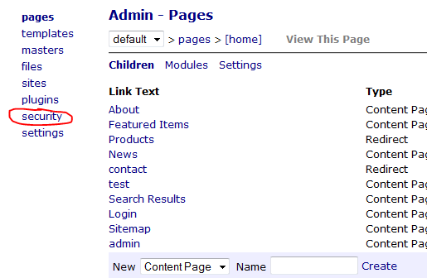

1. at the bottom, enter a user name (no spaces), enter a password twice, press ‘Create New User’

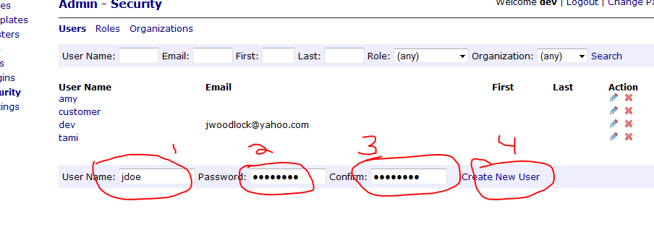

1. enter the user’s mail address, first and last name, and choose save

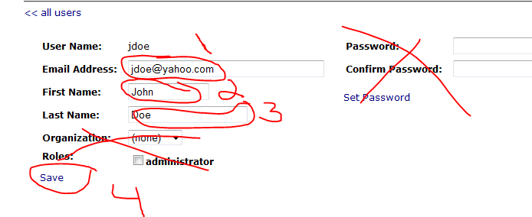

**NEXT TRY OUT THE LOGIN**

1. Log out at top right,

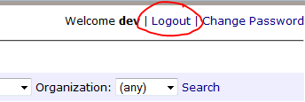

1. go to the plant catalog page
2. select the ‘A’ plants
3. click ‘Login to View Prices’

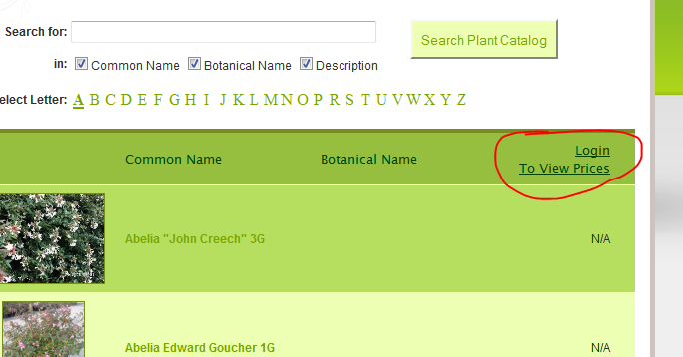

1. Login with new user / password
2. verify that the prices are displayed